"Non-Parametric method application for Sleep Stages recognition "

Gaia Vettori & Filippo Castellani

A hypnogram is a representation of a patient’s sleep stages, derived from the inspection of an EEG recording taken during the night, as a function of time.

“Sleep stages” are a way of classifying the various behaviours shown by the brain while the subject is asleep.

Brain waves are categorized in five classes, differentiated by the characteristic amplitude and frequency range.

However, the waves recognized during sleep are a subgroup of those.

Brain waves associated to sleep are firstly divided into REM and nREM activity:

Rapid Eye Movement waves, as the name suggests, entail an intense activity of the muscles controlling the eyes without sending any visual information to the brain.

On the other hand, the non-Rapid Eye Movement state comprehends 4 sleep stages, each characterized by a brain wave.

The first sleep stage is Stage 1, which shows a high dominance of the alpha wave. The alpha wave is characterized by a low amplitude and medium high frequency, with ranges respectively from 30 to 50 μV and from 8 to 12 Hz. Stage 1 is the state associated to the lightest sleep and is also called the “dozing off” stage. In this period, the beta waves of wakefulness are slowly replaced by the alpha waves. If uninterrupted, it can be as short as 5 minutes and only present at the beginning of the sleep process, directly followed by stage 2.

Stage 2, by contrast, is repeatedly present throughout the night. It is the second stage of the process, after stage 1 and its characteristic wave form is the theta activity, with higher amplitude than alpha (50-100μV) and lower frequencies (3-8Hz). This recording is the one that shows occasional sleep spindles with duration up to 1 second and slightly higher in amplitude.

After the initial stage 1 and its subsequent stage 2, the rest of sleep is composed of an alternation of stage 2, deeper stages of sleep (stage 3 and 4) and the REM activity. Dement and Kleitman characterised the two deeper stages by recognising the associated wave with high amplitude and low frequency (the delta wave) and distinguishing whether it showed presence of sleep spindles. The delta wave presents amplitude higher than 100μV and frequencies between 1 and 4 Hz. In more recent studies, what Dement and Kleitman called stages 3 and 4 have been conventionally nominated as the Deep Sleep stage.

The research conducted by Dement and Kleitman concluded that eye movement periods appeared during the night in all subjects, with an average of 4 times in 6 hours, and appeared in clusters, divided by time intervals up to 5 minutes. The background pattern to the eye movement periods was of the stage 1 kind, so frequencies of 8 Hz and higher (alpha and beta waves). The difference between the stage 1 at the onset of sleep and the ones during deeper stages of sleep, is that the one at the beginning shows a gradual progression from wakefulness to deep sleep, whereas the later stages are more constant with random variations. Body motility was also monitored throughout the night and classified as either major movements or minor movements depending on whether it involved the whole body or just the face. Major body movements appeared mostly during stages of deep sleep and were accompanied by an upward swing of a cycle, meaning the appearance of the stage 1, while minor movements were usually followed by spindling. Eye movements usually ended before the beginning of body movement periods and restarted after them. Finally, the stage 1 at the onset of sleep was taken under consideration and it resulted that it doesn’t show any eye movements and the subjects described that phase as dream-like but clearly different from dreaming.

The signal examined was recorded with an Epilog sensor, which records a single channel of EEG through gold electrodes with a diameter of 6 mm, spaced 18 mm centre-to-centre and data is extracted from the sensor’s onboard memory. It’s a monopolar derivation, located on the right side of the forehead and provides a 9-hour long EEG.

The original signal presents some noise at 60 Hz and is already filtered between 0.8 and 92 Hz.

The filters that we have designed aim to cancel the 60 Hz noise and to provide a further selection of frequencies between 1 and 90 Hz.

The first filter is a Butterworth stop band filter of order 20, with twenty zeros at 60 degrees and ten couples of poles placed in a circular layout. This filter type was believed to be the most appropriate for the purpose because it was highly selective, since it only eliminates the frequencies between 59.8 and 60.2 Hz, with negligible attenuation around the stop band.

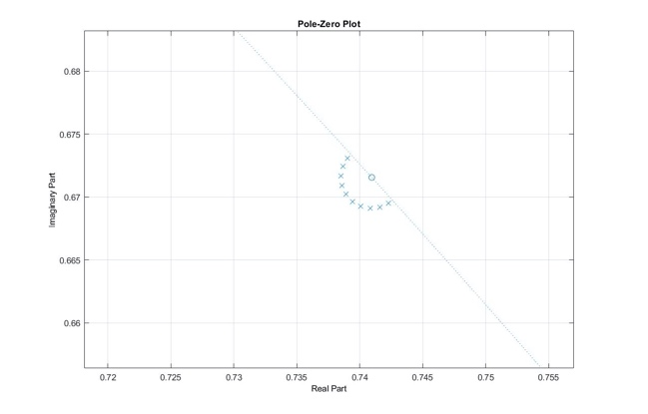

The second filter is a pass band filter and was designed to select a narrower interval of frequencies and eliminate unnecessary ones. It was obtained after a series of attempts and evaluations. The first attempts analysed the optimal filter order. Between an IIR passband filter of order 2, order 10 and 20, it was assessed, as expected, that the higher order filter had the best selectivity. Through simulations, it was verified that the second order filter caused the filtered signal to actually have an amplification around the low frequencies, which was problematic for the analysis we will discuss next. Therefore, a higher order was implemented. The tenth order filter also showed amplification at low frequencies and was hence discarded. Finally, the twentieth order filter was experimented, and did not show any amplification. In fact, it attenuated the signal at very low frequencies. So we designed a filter of order 20, through the Matlab function filterDesigner which resulted to be the optimal choice, since it had a sufficient selectivity and did not show any attenuation nor amplification in the band of interest.

Neither of the two chosen filters has a linear phase, which is why the filtering method filtfilt was picked.

Successively, the code aims to classify the signal based on the dominant recognized wave pattern. The Power Spectral Analysis is done according to the Welch method, choosing epochs of 30 seconds and windows of 10 seconds.

The choice of the epoch length was made by following the AASM (American Academy of Sleep Medicine) rules that recommend 30 second epochs. The choice of the Hann window length for the PS Analysis was made after evaluating the minimum temporal window necessary to analyse the waves of interest (slow waves were the ones putting constrains on the minimum length of the window). Delta waves are the slowest ones, with a frequency range from 1 to 4 Hz and a time period up to 1 second. The Welch method was applied with an overlap of 50%.

An additional variable epoch_jump was initialized and used to have an overlap between epochs, in order to have a greater resolution of the resulting plot.

The function power_in_bands() was created in order to:

apply the pwelch() Matlab function on 30 second epochs with 10 second windows over the entire signal and store the obtained values in vectors D (delta), T (theta), A (alpha), B (beta), according to the corresponding frequencies for each wave.

The beta wave was chosen to characterize the REM sleep. Dement and Kleitman’s paper stated that the Rapid Eye Movement periods happened during the stage 1 and increased its frequency. In order to characterise the stage 1 at the onset of sleep and also the subsequent ones throughout the night, we have decided to define the vector B to recognise the beta waves that range from 12 Hz to 30 Hz, which allows us to assert when REM activity is very likely to be present.

From the plotted results we can see each wave component over the 1200 epochs, but it is not yet possible to recognize any stage with certainty.

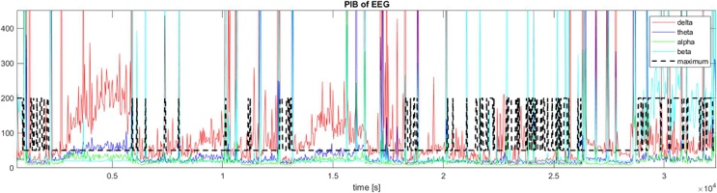

Therefore, the vector I is created for the purpose of recognizing the winning component in each epoch. The vector R simply translates the indices into ordered values following the standard hypnogram.

The resulting plot of -R outlines a very unstable graph whose general behaviour can be spotted. The initial part of the graph starts out as REM activity because it coincides with the frequency range of the beta waves of wakefulness and then descends to deep sleep. Throughout the night, a cyclic pattern of oscillations between deep sleep and REM emerges, with some alternation with the stage 2 in a specific period of the night. At the end, the REM activity can be recognized which is coherent with the standard behaviour of healthy sleeping subject.

However, the instability of the classification causes the plot to be very different from a hand-made hypnogram, therefore the function sliding_assignment was designed.

This function, with the help of prority_mode, also designed for this purpose, has the task of stabilizing the winning index plot, sometimes prioritizing the losing stage. This reasoning was based on following a standard hypnogram realization. Analysists working on polysomnograms, such as the ones that collaborated on Dement and Kleitman’s paper, produced hypnograms with stages about 30 minutes long, where it is safe to assume that definite and abrupt changes between stages were sketched after a cautious amount of time. For this reason, we chose to apply a modified mode function over windows of 18 minutes and with a threshold that allowed a sufficient resolution. Too many oscillations were caused by very low thresholds, and high thresholds produced a very constant graph and the absence of some sleep stages. Therefore, in the intervals where there’s an evident REM activity, surrounded by oscillations to the deep sleep stage, these functions prioritize the losing REM brain wave, if present in a percentage higher than a defined threshold.

The optimal values of the window length m and the threshold were obtained after various trials. A very high threshold caused the signal to lose any presence of stage 2 activity and a very narrow window produced high oscillations.

The final product is a hypnogram very similar in appearance to the ones from Dement and Kleitman paper and also coherent with the expected healthy behaviour. Four to five cycles are visible in 9 hours, which is congruous with the average 4 in 6 hours of D&K’s paper. The initial stage starts off at high frequencies and slowly decreases. The final stage ends at the REM level which could either mean that the patient has woken up, or it could represent the last REM cycle before the awakening.

